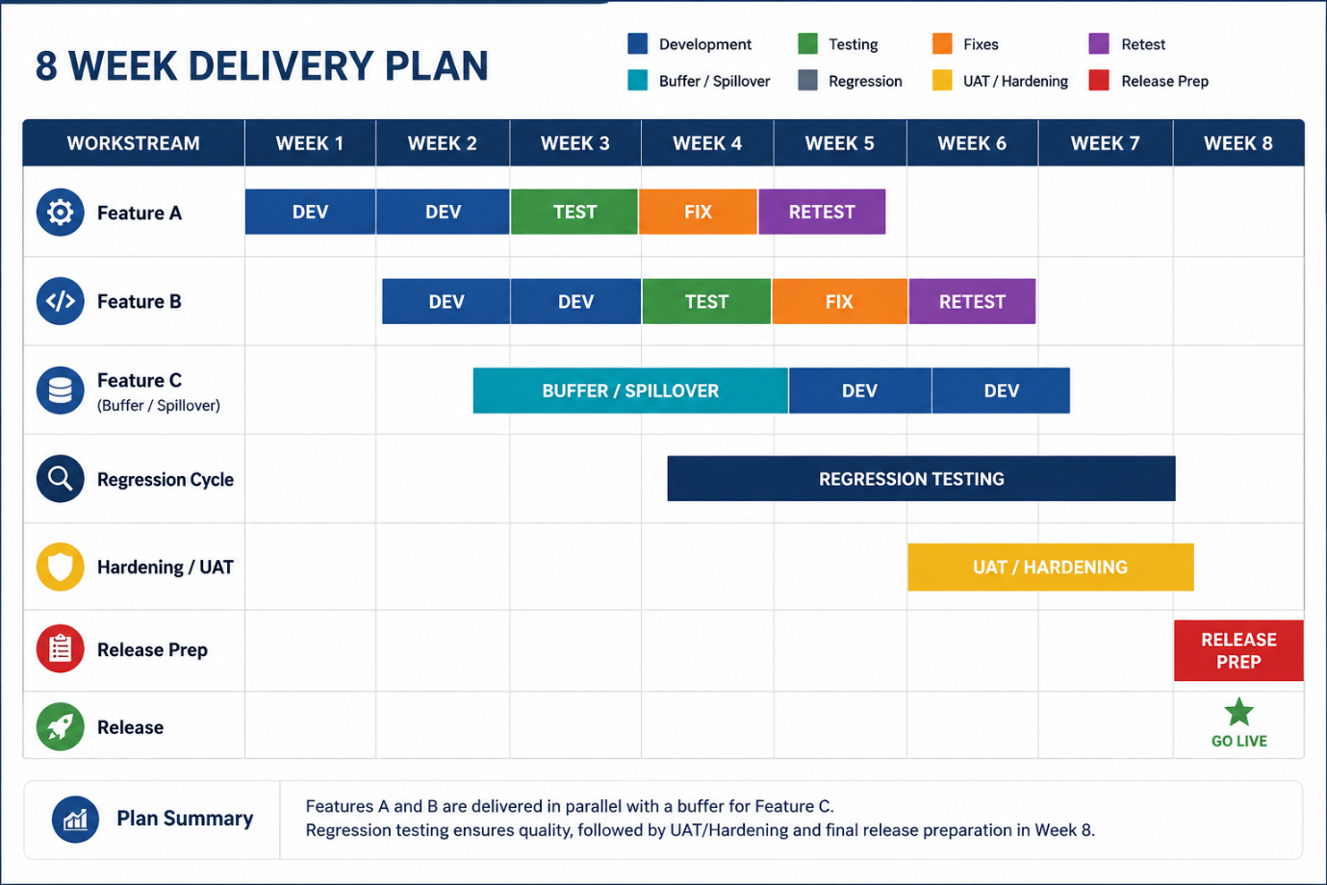

8-Week Delivery Plan Explained
The objective of this plan is to deliver three features while maintaining quality through structured testing, regression, user acceptance testing (UAT), and release preparation.
Weeks 1–2: Build Feature A
The team starts by focusing on Feature A.
During the first two weeks we:
- Gather any final requirements
- Complete development
- Perform developer testing
- Prepare the feature for formal QA
The goal is to get the first major piece of functionality built and stable as early as possible.

Weeks 2–3: Build Feature B
While Feature A moves into testing, development begins on Feature B.
This allows the team to work efficiently in parallel rather than waiting for Feature A to complete completely.
By the end of Week 3:
- Feature A is entering testing
- Feature B development is largely complete

Weeks 3–5: Testing and Fixing
Once Feature A is developed:
Week 3
Feature A enters formal testing.
The QA team validates:
- Functional requirements
- User journeys
- Edge cases
- Integration points
Week 4
Any issues found are fixed.
Week 5
Retesting confirms the fixes work correctly and have not introduced new defects.
The same process then follows for Feature B shortly afterwards.

Weeks 4–5: Buffer and Spillover
Projects rarely run exactly to plan.
The buffer built into the schedule provides protection against:
- Delayed requirements
- Unexpected technical complexity
- Resource constraints
- Production support interruptions
Instead of immediately impacting delivery dates, the project can absorb small delays here.

Weeks 5–6: Feature C Development
Feature C is intentionally scheduled later.
This provides flexibility because:
- Requirements may still be evolving
- It is lower priority
- Lessons learned from Features A and B can be applied
The team uses the buffer period and then develops Feature C in Weeks 5 and 6.

Weeks 4–7: Regression Testing
Regression testing runs across multiple weeks.
The purpose is to ensure that:
- New changes do not break existing functionality
- Features work together correctly
- Integrations remain stable
This is particularly important when multiple features are being delivered in the same release.
Think of regression testing as the project's safety net.

Weeks 6–7: UAT and Hardening
After development and regression testing are complete, the project moves into:
User Acceptance Testing (UAT)
Business users validate that:
- The solution meets business needs
- Workflows function correctly
- Reporting and integrations behave as expected
Hardening
The technical team focuses on:
- Performance improvements
- Security reviews
- Stability improvements
- Production readiness
The objective is to remove any remaining risk before release.

Week 8: Release Preparation
The final week is reserved for deployment readiness.
Activities include:
- Release documentation
- Deployment planning
- Rollback planning
- Final approvals
- Release communications
No major development should occur during this stage.
The focus is entirely on delivering safely.

End of Week 8: Go Live

